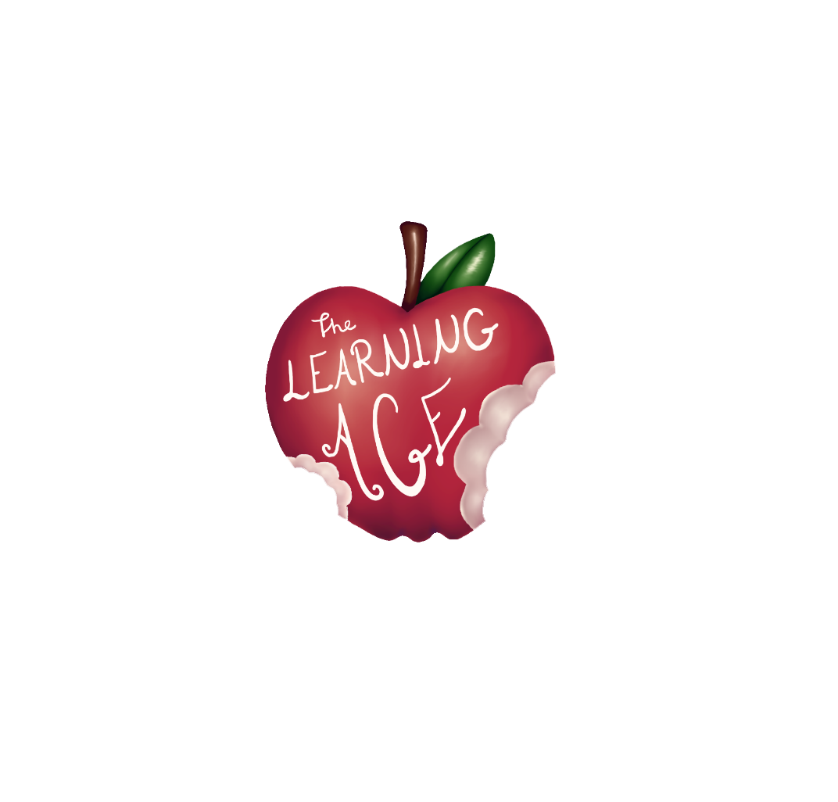

Project: AGE – The Learning Age. Intergenerational learning for commit together as citizens of the XXI century

THE LEARNING AGE

Training material for young people

Funded by the European Union. Views and opinions expressed are however those of the author(s) only and do not necessarily reflect those of the European Union or the European Education and Culture Executive Agency (EACEA). Neither the European Union nor EACEA can be held responsible for them.
Premises

The following content is the result of the knowledge and field experience of “The Learning Age” Erasmus+ project partners through the years with both young and senior users of their organizations’ activities. The author of each unit has been assigned respecting the expertise of every partner.
The first edition of the training for has been delivered for the first time in the frame of the AGE project between April and May 2023, from Fundacja Autokreacja and Stowarzyszenie Szukamy Polski in Poland, Team 4 Excellence in Romania, Fundación Rondilla y Asociación Deses-3 in Spain. Each organization involved 5 youngsters and young adults between 14 and 30 years old from the local community, and set the basis for the intergenerational meetings afterwards, where the digitalization of senior participants has been centric, as well as communication and friendship.

Index

Unit 1: Andragogy. Who is the senior? 5
Introduction 5
Learning objectives 5
Topics 5
What is Andragogy? 6
History and Development of Andragogy 6
Benefits of Andragogy for Senior Learners 7
The Aging Process and Its Impact on the Senior Learning Needs 7
Further reading 8
Bibliography 8
Unit 2: Working empathy with the senior 9
Introduction 9
Learning objectives 9
Topics 9
Definition of Empathy 10
Main difficulties experienced by seniors in learning 11
Activities to train empathy while working with seniors 13
Further reading 14
Bibliography 14
Unit 3: Intergenerational Co-learning 15
Introduction 15
Learning objectives 15
Topics 15
Definition of intergenerational co-learning 16
Benefits of intergenerational co-learning 17
How to create a co-learning intergenerational events or programmes 18
Further reading 19
Bibliography 19
Unit 4: Basic aspects of tools to be used for the Lean to Learn channel 20
Introduction 20
Learning objectives 20
Topics 20
Learn to Learn Intergenerational co-learning Platform 21
An introduction to YouTube channel 21
How to Video Record from a Mobile Phone 22
How to edit a video using the Splice App 23
Further reading 24
Bibliography 25
Unit 5: Production of a video content 25
Introduction 25
Learning objectives 25
Topics 25
Video Dictionary 26
Video Shooting 28
Video Editing 29
Further reading 30
Unit 6: Post-production of an online video 32
Introduction 32
Learning objectives 32
Topics 32
How to use CapCut App 33
Introducing the CapCut Interface 33
How to do basic editing in CapCut 34
How to Split Clips in CapCut 35
How to Resize Videos in CapCut 36
How to Mirror Video in CapCut 37
How to Rotate Video in CapCut 37
How to Change Speed in CapCut 39
How to Reverse a Video in CapCut 40
How to Replace a Clip in CapCut 40
How to Add Video Transitions in CapCut 41
How to Use Overlays in CapCut 42
How to Put Two Videos Side by Side in CapCut (or Create Split Screen Effect) 43
How to Use Green Screen in CapCut 43
How to Edit Text in CapCut 44
How to Make Text Transparent in CapCut 44
How to Use Text Tracking in CapCut 45
How to Create the Text Behind Person Effect 46
How to Edit Audio in CapCut 46
How to Change Audio Volume in CapCut 47
How to Use Auto Caption in CapCut 47
How to apply advanced editing in CapCut 48
How to Make a Picture Move in CapCut 48
Will I Lose Everything If I Delete CapCut? 49
How to Export the Video from CapCut 49
How to upload a video to the YouTube channel 49
Further reading 53
Bibliography 53

Unit 1: Andragogy. Who is the senior?

Introduction
Andragogy, or adult learning theory, is a field of study focused on understanding the needs and strategies for teaching adults. As our population continues to age, it is increasingly important to understand the needs of the senior learner and develop effective strategies for teaching and engaging them in lifelong learning activities. In this didactic unit, we will explore the concept of andragogy and discuss who the senior learner is, with a certain focus on the digital learning.
The senior learner is a unique population that requires specific accommodations and strategies to ensure their success. Senior learners bring a wealth of knowledge, experience, and perspective to the classroom, but require specific provisions to ensure their success. It is essential to understand the needs of the senior learner and provide the necessary arrangements to ensure their success in the classroom, as well as in the online environment where always more of their activities are taking place.

Learning objectives
- Identify the key components of andragogy and how it applies to the teaching of senior learners.
- Describe the physical and cognitive changes that occur with the aging process and their impact on learning.
- Identify the needs of senior learners in the classroom or online and develop strategies for teaching and engaging them.
- Attain the ability to create an engaging learning environment for senior learners.
- Explain how to leverage technology to enhance senior learner engagement.

Topics
- Defining Andragogy, its History and Benefits for the Senior
- Understanding the Needs of the Senior Learner

Estimated duration of the unit delivery: 2 hours.

What is Andragogy?
Andragogy is a concept developed by German educator and theorist Alexander Kapp in the late 1800s, which refers to the study of adult learning. It was developed in response to the traditional pedagogical methods of teaching children, which Kapp felt were inadequate for teaching adults. Andragogy is based on the assumption that adults are self-directed, self-motivated, and require different approaches to learning than children.
In the simplest terms, andragogy is the study of how adults learn best. It is a theory that seeks to understand how adults learn differently than children, and how educators can best engage with adult learners. Andragogy is an extension of pedagogy, the study of teaching children, and it focuses on the needs of adult learners.
Andragogy is based on the idea that adults are self-directed and autonomous learners who are capable of making decisions and taking responsibility for their own learning. It is based on the belief that adult learners are motivated to learn by their internal goals, needs, and interests.
Moreover, Andragogy is also based on the idea that adults are knowledge-rich and bring a wealth of experience to the learning process. This experience can be used to inform the learning process and can be tapped into to provide meaningful learning experiences.
Andragogical methods of teaching are typically more student-centered and interactive than traditional teaching methods. Instructors often use discussion, collaborative learning, experiential activities, and problem-solving to engage adult learners. These techniques are designed to help adult learners develop critical thinking and problem-solving skills.
In conclusion, andragogy is an important field of study that has been in use for centuries. It is based on the idea that adults are autonomous learners, and it is for that reason that educators have to find diverse tools and resources to continuously engage their adult students in meaningful learning experiences.

History and Development of Andragogy
As briefly advanced, the term Andragogy was first coined in 1833 by German educator Alexander Kapp to describe the study of adult education, and has since been used to refer to the theory and practice of adult learning. Andragogy has evolved over the years, and today is considered a valuable part of the education process.
The history of andragogy can be traced back to the late 19th century, when Alexander Kapp developed the concept of andragogy to address the unique needs of adult learners. Kapp believed that adults had different needs and learning styles than children, and he sought to create a framework for teaching that would respect these differences. His work was eventually adapted by American educator Malcolm Knowles in the 1950s and 1960s, who developed the idea of “andragogical principles” that would become the basis for modern andragogy.
The development of andragogy since then has been influenced by a variety of factors, including the rise of technology and the changing demands of the modern workplace. As technology has advanced, so too has the ability to deliver educational content in innovative ways that better meet the needs of adult learners.
In addition, the changing demands of the modern workplace have pushed educators to focus more on teaching skills that are applicable to the real world, such as problem-solving and critical thinking. This has led to a greater emphasis on andragogical methods that focus on student-centered and interactive learning experiences.
Today, Andragogy is used in a variety of settings, from professional development courses to college classrooms, and a variety of industries also make advantage of it, from healthcare to business, to provide employees with the knowledge and skills they need to succeed.

Benefits of Andragogy for Senior Learners

Andragogy has many benefits for senior learners, especially for those who are looking to stay engaged and continue learning. One of the main benefits of andragogy for senior learners is the opportunity to feel worthy and able to do something: the usual attitude of elder people is to feel like they are no longer able to keep up with the latest knowledge and skills. Andragogy provides a way for seniors to still take part in learning with tailored-made learners activities.

Andragogy also provides seniors with the opportunity to develop new competence. With adult education seniors can feel up-to-date on news, technology and trends on different fields, keeping up with the changing world.

Finally, andragogy also benefits seniors with the opportunity to connect with other learners. As they can often become isolated from the larger learning community, Andragogy provides a way for seniors to connect with other learners and engage in meaningful conversations, fostering inclusion. This can help seniors to feel connected and supported, which can help to improve their overall wellbeing.

The Aging Process and Its Impact on the Senior Learning Needs
As people age, their bodies and minds undergo a series of changes that can have a profound impact on their learning. The aging process can cause physical changes such as reduced hearing or vision, slower reactions, and an increased risk of injury or illness. It can also cause cognitive changes such as reduced attention span and difficulty learning new skills or concepts.
In the classroom, senior learners may have difficulty keeping up with the pace of instruction or have trouble understanding complex material. They may require more time to complete tasks or need additional help to comprehend the material. Additionally, they may have difficulty with physical activities, such as standing or walking, that are required in some learning activities.
It is important to recognize the impact of the aging process on senior learners, and take steps to accommodate their needs. In order to do that, educators must develop and practice empathy (subject of unit 2) with their senior learners, especially when the media used or the topic treated is related to technology. As non-digital native extra support can be needed to provide the right competences.
Moreover, it has to be recognized that the aging process can also have an emotional impact on senior learners. They may feel overwhelmed or frustrated by the changes in their body or mind. They may also feel isolated or lonely as their peers move on to different stages of life. For this, it is important to provide a supportive environment, both showing sensitiveness and adjusting the class equipment to their needs.

Further reading
Adult Learning Theory | Knowles' 6 Assumptions of Adult Learners. https://www.youtube.com/watch?v=SArAggTULLU

Bibliography
Knowles, M. S. (1970). The modern practice of adult education: Andragogy versus pedagogy. New York: Association Press.
Merriam, S. B., & Bierema, L. L. (2014). Adult learning: Linking theory and practice. San Francisco: Jossey-Bass.
Smith, M. K. (2013). Understanding and promoting transformative learning: A guide for educators of adults. San Francisco: Jossey-Bass.
Taylor, E. W., & Kroth, M. (Eds.). (2009). Teaching and learning for the twenty-first century: Educational goals, policies, and outcomes. New York: Routledge.
Tisdell, E. J. (2015). Teaching adults: A practical guide for new teachers. San Francisco: Jossey-Bass.

Unit 2: Working empathy with the senior

Introduction
Empathising with someone means disposing oneself to wear someone's shoes and being able to understand, despite a gap or mismatch between you and the person you are empathising with, for generational, emotional, or social reasons.
With this didactic unit, young people, who will be meeting seniors and working with them to teach them about mobile phones, mobile applications, video making, and content editions, will learn more about the concept of empathy, how to improve this skill and establish healthy communication. Therefore, future activities facilitators will understand the physical and cognitive difficulties seniors might experience in the attempt to learn. Finally, through two activities, by the end of this unit, young facilitators are given the chance to prepare themselves for encounters with seniors and put into practice the precious tips on how to train empathy in working with seniors.

Learning objectives
- Knowing the features of empathy, its benefits, and how to improve it
- Understanding the type of difficulties seniors can have in learning
- Acquiring the ability to interact properly with a senior learner.

Topics
- Definition of empathy
- Main difficulties experienced by seniors in learning
- Activities to train empathy while working with seniors

Estimated duration of the unit delivery: 2 hours.

Definition of Empathy
Empathy is defined as "the ability to share someone else's feelings or experiences by imagining what it would be like to be in that person's situation” (Cambridge Dictionary). This skill is strictly related to a sensitive attitude of a person towards another who might identify with that person, despite the different status or emotional situation this individual is living. Being empathetic is indeed a very important social skill that allows one to develop emotional intelligence, active listening, better communication, and an overall sense of well-being that determines self-esteem and consciousness.
An empathetic person is usually someone who is:
- tolerant and respectful towards the differences that there can be with the individual they are empathizing with;
- believing in the trustworthiness of people;
- understanding the meaning after the gestures, glances, and all the other reliable signs constituting non-verbal communication. Not always an empathetic person is an extrovert, but for sure is a good listener and a careful observer;
- talking very carefully, not to hurt the sensitivity of the person they have in front;
- able to solve conflicts and face issues with no prejudices or pre-concepts.
It is not said that all people are empathetic to the same degree, or empathetic at all, but as a social skill, this can be trained and improved by following a series of steps:
- know yourself. You will only be able to help someone else if you help yourself first. Your moods and actions are indications of what you need, and learning how to respond to those emotional necessities is essential to improving the knowledge of your feelings, the exteriorization of those, and the overall communication with others;
- observe the untold. Most of the time, the words do not reflect the real status of a person. It is important to catch all the facets of emotional status, even the most imperceptible ones that a gesture or a sight, or a corporal posture can embody. Either way, it is vital to make the other feel comfortable to speak the own truth or burden reality, outspeaking yourself with a calm and reassuring tone of voice and an open corporal posture;
- learn to listen. The act of listening is never a passive action since it presumes a return of that action in the format of feedback, feeding reciprocity that is essential in the circle of communication (sender – message – receiver – feedback – sender). Showing interest while listening is part of the overall understanding process. Only this way you can be empathetic.
In the attempt to be empathetic, it is relevant to get to know who you are being empathetic with, to make the overall process of understanding and communicating effective. As mentioned above, usually, the act of being empathetic requires the effort of getting to feel what someone else is feeling, so if a young person has to work on empathy with a senior, the first has to get over the generational gap and get to know how it is like to be a senior.

Main difficulties experienced by seniors in learning
When empathizing with seniors and working with them, it is important to acquire some knowledge about how different or weaker their physical and mental performance can be. In this regard, the first very important thing to keep in mind is that stereotypes about aging should be forgotten, and replaced with useful advice that respectfully considers certain difficulties that can be detected at a higher or lower level. At the moment of developing learning activities, that may include knowing something new, something they haven’t been native of, such as a foreign language or the functioning of a digital device (the main purpose of this training), there are a series of things to be considered carefully.
In the last scenario, briefly advanced of having to deliver digital education to a group of seniors, the main difficulties a trainer or learning activity facilitator should consider can be listed and categorized as follows.
Attitudinal difficulties:
- thinking about being too late to learn this technology thing;
- being unable to take advantage of it or learn;
- being afraid of being wrong and spoiling it;
- feeling concerned about what others will think of the learning outcome.
Motor issues:
- possible difficulty in handling the mobile keyboard due to size or tremor.
Sensory difficulties:
- possible issues in seeing objects on the screen;
- difficulties in listening to the instructions of the trainer.
Cognitive problems:
- forgetting the information and steps taken when tried with the trainer;
- forgetting the location of mobile applications and others;
- difficulties with short-term memory to follow instructions;
- challenged in understanding complex procedures and explanations;
- being afraid that the current graphical operating systems are not as intuitive as thought.
Spatial orientation:
- difficulty moving around the screen;
- need help in understanding the overlapping of windows, the folder scheme of the applications, etc.
Considering all the above possible limitations, it is relevant to get to know how to motivate seniors to be working on something unknown. Most of the time, engaging seniors in challenging activities is not as difficult as it seems: the key stand in reassuring the person who's taking part in the learning process and create a trusted environment where the senior has listened, and the trainer attentive to modify the own teaching performance in the attempt of creating reciprocity and active cooperation.
More in detail, the engagement of a senior participant in learning activities might depend on the degree of independence that the acquired competencies might provide (think of all the medical dates, administrative staff, and leisure activities those individuals will be able to handle by knowing how to use digital devices and apps), as well as the company that activity brings all together. Nevertheless, the activity facilitator should always be disposed to active listening – as the main empathetic ability – and embody this advised series of attitudes when dealing with a senior audience:
- motivate them to be confident in their own abilities and not be afraid of being wrong;
- have a positive attitude and try to transmit it;
- vocalize well when speaking and measure the rhythm of the explanation;
- use vocabulary with which you can be understood, be careful with technical terms;
- have a close and affectionate attitude;
- respect the audience's learning pace and set realistic learning objectives;
- be observant and creative and adapt to the needs of the person in front of you;
- be careful and detailed in your explanations, supporting them with practical examples;
- respond to the interests of your learner or be able to search for them;
- be curious and renew your skills and abilities;
- orient and guide, but not do for others. You have to help the autonomy of your learners.
Summing up, being empathetic to a senior who's learning means providing support, all-time active listening, and redirecting the educational performance in a way that can be better understood by everyone. Working empathy with a senior also means being able to be asking the right questions and being respectful of the emotional burden that might influence the learning process.
Last but not least, being empathetic can be expressed with some carefulness with regard to creating the spatial and physical welcoming environment for the senior:
- make sure that when exercising the sight, the lights are up, and you are using visual aids;
- check on the class temperature to be optimal for every learner;
- be sure that your voice is loud and clear for all the learners seated at a different distance from you;
- if the activity is developed online, make sure that all leaners have the means and the right instructions to interact through the digital media.

Activities to train empathy while working with seniors
The following proposed activity is meant to make the young facilitator feel what it is like to be a senior, physically and cognitively talking. For this exercise, every used material has to simulate a condition:
- earplugs to diminish the ability to hear properly;
- small rocks into the shoes to make them feel uncomfortable while walking;
- elastic bands to be placed around both ankles to make it even more difficult to walk;
- eye bands or mask that may totally or partially stop them from seeing;
- walking canes or anything that can simulate a walking cane in being uncomfortable.

The proposed activity is a role play where different simulated situations around getting seniors to know digital devices and mobile applications are contemplated. The solutions to the following situation scenarios are covered by the theoretical part of this unit.
- You are addressing a senior who is not convinced of the usefulness of a mobile phone and the Internet. What arguments do you give him to motivate him to get digitized?
- You explain some utility and function of the mobile phone to a senior learner several times, but still, he is not able to assimilate it. What do you do?
- You are dealing with an explanation to a couple of people, and one of them continually interrupts, trying to get your attention and not letting the other participants. How do you manage this situation?
- After organising your senior group in pairs so that they practice a certain functionality of the phone, you notice that in one of the pairs, one of the people does not let the other put into practice what they have learned, taking the device and doing everything himself. How to deal with it?
- One of the elderly people continually requires your attention, reproaching you for not paying attention to her and taking too long to attend to her. How to please her without making her feel bad?
- One of the students insists on writing down all your explanations and frequently interrupts to ask you to repeat a certain procedure, breaking the rhythm of the explanation and causing the discontent of the rest of the classmates. What do you propose?
- One of the students loves to use WhatsApp, but she has a lot of difficulty typing on the keyboard. Do you offer an alternative?

Further reading
Empathy for Everyone? The Effect of Age When Evaluating a Virtual Agent. https://acortar.link/OO6NeP

Bibliography
Acomi, N. (2021) Supporting Elderly. A Practitioner’s Guide. Available at: https://zenodo.org/record/5594887.
“Cambridge Dictionary | English Dictionary, Translations & Thesaurus” (2023). Available at: https://dictionary.cambridge.org/.
Online, P. (2019) ¿Qué es la empatía y cómo desarrollarla? Available at: https://www.psicoglobal.com/blog/empatia-desarrollo.
Rondilla, A. (no date) Mayores Apptivados: Formación en el uso de dispositivos móviles e internet para mayores. Available at: https://rondilla.org/post/mayores-apptivados-formacion-en-el-uso-de-dispositivos-moviles-e-internet-para-mayores/.

Unit 3: Intergenerational Co-learning

Introduction
Great events and catastrophic ones seem to have traced several differences from one generation to the other. Today, technology seems also to be driving the main gap between a nephew and a grandparent in what is acknowledged to be the digital divide. Nonetheless, lifelong learning offers the chance to be creating synergies and connections among the younger and elderly, showing a sense of belonging to a community and a society that can create value at all individuals' life stages.
In this didactic unit, future young facilitators who will take part in intergenerational encounters on the topics of technologies, ICTs, and digital content edition, will learn what makes generations different from another, what intergenerational co-learning is, and how to effectively organize such type of events and activities with a clear educational asset.

Learning objectives
- Knowing the features of a generation and what makes learning intergenerational
- Understanding the concept of co-learning
- Acquiring skills and attitudes to organize intergenerational educative events/programmes.

Topics
- Definition of intergenerational co-learning
- Benefits of intergenerational co-learning
- How to create a co-learning intergenerational events or programmes.

Estimated duration of the unit delivery: 2 hours.

Definition of intergenerational co-learning
What determines a generation? How is it changing? Has it a biological or a social reason to be?
For starters, a generation is referred to as a group of people with something in common. If the biological factor is taken into consideration, a generation is a way to calculate the age of mankind based on the genetic material perpetuating from one family role to the other, in a cyclic way. But, if we refer to the social phenomenon, a generation can trace the progress of mankind, through the evident evolution in science and technology, and history, with specific meaningful events that group up individuals for lifestyle, including consumption habits, such as:
- Silent Generation (1928 – 1945) with the Great Depression and the Second World War;
- Baby boomers (1946 – 1964) witnessed the starting of great economic well-being;
- Gen X (1965 – 1980) signed by the end of the Moon Landing and the end of the Cold War;
- Millennials (1981 – 1996) signed by September 11 and a highly progressing tech revolution;
- Gen Z (1997 – 2012) with the invention of social networking and all supporting ICTs;
- Gen Alpha or Echo boomers (2013 – ahead) witness a great need for sustainability in a highly digitalized world.
So, when a term is accompanied by the adjective "intergenerational" that means different age groups people are involved, with their different social and historical backgrounds, and diverse habits indeed.
If this concept is applied to learning, that assumes the meaning of an exchange between people that have born in a different social context, especially a digital one. From the Millennials generation ahead, digital transformation has influenced every aspect of daily life.
The latest generation is authentic digital natives, and so are experts in every aspect of dealing with technology. On the other hand, Baby boomers and Gen X adherents are the ones you may afford to draw from their own life experience, especially regarding job performance and family cohabitation. In the attempt of learning from each other, the intergenerational co-learning seems to address several issues of the current historical moment, in both lifelong learning of seniors – in need of acknowledging the digital transformation influencing their daily life and degree of independence -, and of youth, always more afflicted by early-school leaving and unemployment.

Benefits of intergenerational co-learning
Despite its challenging character, intergenerational co-learning enhances a series of benefits for the two generations involved in it, such as increasing solidarity and contributing and sharing knowledge, values, and experiences. Specifically, seniors can result being benefited from intergenerational co-learning in the following ways:
- improved self-esteem and mood, thanks to maintaining social relationships and installing companionship with other generations;
- greater vitality, and increased activity and energy to continue enjoying everyday life with a positive attitude and a greater vision of their future;
- decreased feelings of loneliness as social relationships and activity increase;
- integration and sense of belonging, feeling like being an important member of a community;
- continued learning, as the knowledge is expanded thanks to the exchange that occurs between generations.

As for the younger generations, intergenerational co-learning means:
- changing their perception of a senior person. Knowing and enjoying time with older people causes a great switch in how a senior has been seen until that enlightening moment of sharing;
- being able to access support networks. Thanks to this type of relationship, their support networks are expanded and are not limited to those of the same generation;
- knowing the issues that affect the elderly. Youth becomes aware of the main concerns of seniors and gets familiarized with what their future will look like;
- increasing social responsibility, active citizenship, empathy, or self-esteem. With intergenerational relationships, values, and civic activism increase;
- continued learning and youth knowledge increases based on less scholarly and structured ways of learning, such as informal and non-formal education methodologies arising thanks to intergenerational exchanges.
So, if a senior interacting with a younger person enables the first one to acquire skills, for a young person interacting with a senior means finding an experienced model to follow to evolve in life.
Overall, intergenerational learning contributes enormously to the diversity of perspectives so displayed, as well as creates a habit of treating so many different topics meant to fill the gaps and lack one another. This way, by empowering a group of people of different ages with distinct skills and knowledge, a whole community may result empowered, creating relevant social capital, based on cooperation. This way to a certain problem or necessity, the different generations can cover the lacks and produce value, together.
The concept of community itself whose main aim is to grow in the framework of a constantly evolving world makes it possible to apply intergenerational co-learning in different aspects of life, starting, for example, from creating a long-lasting memory of folklore, traditions, heritage, and culture which seniors are guardians. Not to forget actions involving the respect of the environment and civic participation in democratic life, which certainly allow younger people to come back to a simple and more sustainable life. On the other hand, several educational activities required by adult education centres are oriented to make adults and seniors familiar with foreign languages and digital devices, as in need to know this globalized planet, towards whom it is crucial to acquire a critical thinking attitude.

How to create a co-learning intergenerational events or programmes
May the purpose of the intergenerational co-learning event or programme be the creation of an urban garden, a workshop about fake news, or another on how to book a visit at the doctor through a mobile application, this kind of activities needs a certain preparation, and overall organization for its successful implementation.
Considering the purpose of socialization of such co-learning experience, and the development of interpersonal relationships between the elderly and young people, the latter should be asked to take charge of the preparation for a heterogeneous group of seniors for an intergenerational co-learning event/programme to train responsibility and getting useful experience-driven wisdom about it. The focus will be on the constructive use of adults' and seniors' free time and voluntary learning process, together with the life and professional experience seniors can be role models for the younger generation. In the attempt to fulfilling such an organization, it is important to focus on socializing and create a clear basis for the upcoming demanding activities.
Identifying the objectives and establishing the benefits of the method to be applied: before starting the process of organizing, any organizer, together with the programme/event team, must be aware of the motivation for which to create an activity and the objectives pursued after its development. It should be noted that each team member fully understands the purpose of the method and its benefits to the community to which they belong.
Responsibilities of the young previously trained team: the organizer could care about all those logistics matters that make the difference between a good activity and a not-that-good one. For that, human resources, and people involved to be managed during the event/programme should be taken into account.
Choosing the location for organizing the event: a spacious location where feeling relaxed is needed. There must be enough tables and chairs, and possibly supportive equipment such as a projector, a computer, and a screen where to project. Therefore, it is recommendable an open space that provides insight into all participants in the event, and where the latter can decide to sit and dialogue.
Implementation of the event/activity of the programme: before any more technical sessions, it could be helpful to break the ice through short group dynamics that aim at getting to know each other, or reminding names if it is not a single-time event. Therefore, after a pair of playful group activities, it would be good to start the proposed activity for that precise encounter with great energy, considering stopping and leaving time for the exchange of opinions every half hour.
Evaluation: a group dynamic is proposed once the event/activity is closed, among all the participants. The initially fixed objectives have to be proven fulfilled. To do so, an assessment dynamic, a game, or a quiz is advised (for example, Kahoot). It is also recommended to provide a space for suggestions for improvements of the next activity of the programme, or calendared event.

Further reading
Ted Talk “What baby boomers can learn from millennials at work and vice versa” https://www.ted.com/talks/chip_conley_what_baby_boomers_can_learn_from_millennials_at_work_and_vice_versa

Bibliography
The Generational Power Index Report 2021. Visual Capitalist Canada (2021). Available at: https://www.visualcapitalist.com/wp-content/uploads/2021/05/generational-power-index-2021-1.pdf
Schmidt-Hertha, Bernhard, curatore. (2014) “Learning across Generations in Europe: Contemporary Issues in Older Adult Education.” Available at: https://www.um.edu.mt/library/oar/bitstream/123456789/1429/1/SchmidtHertha%2C%20Krasovec%2C%20and%20Formosa%20-%20Learning%20across%20generations%20in%20Europe.pdf.

Unit 4: Basic aspects of tools to be used for the Lean to Learn channel

Introduction
In this didactic unit, future young facilitators who will take part in intergenerational encounters with senior people on the topics of technologies, ICTs, and digital content edition, will learn about topics, useful on what they will be doing together.
The first topic is the “Learn to Learn” platform, the second topic is an introduction to YouTube, while the third topic is on video recording using the mobile phones. The final topic of the unit is about editing the videos using the Splice mobile app. The latter will be just one of the few mobile applications advised for the purpose of this project, aiming at making the procedure better, easier and more enjoyable for the target group.

Learning objectives
- Usage of the mobile phone devices to record videos
- Edition and customization of the recorded videos through a mobile app
- Approaching learning as problem-solving and creativeness.

Topics
- Learn to Learn Intergenerational co-learning Platform
- Video Recording (Mobile phone)
- Editing Tools (Splice Android/iOS app)
- YouTube Channel

Estimated duration of the unit delivery: 2 hours.

Learn to Learn Intergenerational co-learning Platform
In the context of “The Learning Age” Erasmus + project in field of adult education, a platform has been developed with the aim of creating and supporting an international and intergenerational community of educators and their adult learners. In the platform, successful projects and programmes (good practices) in intergenerational co-learning methodology are hosted, and categorized into 6 branches: culture, citizenship, critical thinking, environment, health/wellness, and technologies. A forum has also been enabled in the platform for creating a community, to discuss on the good practices, and connect transnationally in the matter of adult and senior education.
Through the delivery of this training for young adults, a serious of intergenerational meetings will follow, and the main output of these will be the creation of a YouTube channel of audiovisual reproduction of intergenerational co-learning, "LEARN TO LEARN" (https://trainingclub.eu/age/) . Main characters of the videos will be seniors, providing tutorials or videos upon very different topics: family and values, citizenship and responsibility, labor market and work careers, education, health, environment, and economy. Life experiences will orient the main videos ideas, which final result will be available in the “Learn to Learn” intergenerational learning platform.
The project has the scope of providing an intergenerational reference about intergenerational co-learning. The platform will be available to institutions, entities, groups and professionals that work with senior adults and aims to cover their needs and provide them with different tools and resources at the level of intergenerational learning to improve their work.

An introduction to YouTube channel
YouTube is free video sharing website that allow its users to upload own video content by creating a channel, but also watch, like, and comment others’ audiovisual materials too. For now, it is a free service, and it is widely regulated under GDPR, which protects more vulnerable audience form inappropriate content, such as children, and copyright, that avoids sharing content without third-party consent.
Principles benefits of YouTube channel is the opportunity to create something of one’s own, and widely share it, for a better acknowledgement of the original content. In some cases, users turn to YouTube to keep up with the latest news or just to learn about a trend topic. For content where accuracy and reliability are critical, such as news, political, medical and scientific information, the same YouTube website uses machine learning systems to prioritize information from trusted sources and provide context, so users can make an informed decision.
For this reason, “The Learning Age” consortium has selected this website to start an intergenerational co-learning channel, where seniors will at first learn about YouTube, and then provide with life experiences the videos scripts and recording of their own making, while the young adults, to whom this training has been delivered to, will help out seniors to edit the produced videos.

How to Video Record from a Mobile Phone
Providing rich interactive tools is the key feature of the learning experience, enabling the learners to access tools that support their learning skills. Using different but simple video-related tools makes it possible to improve their knowledge in several ways and facilitates different forms of interaction with learners. In addition, using basic aspects of the editing tools encourages the learners to be educated more, providing their own resources to ensure they have the skills to deliver rich, engaging content. Throughout these experiences, all these tools have become available for creating and capturing learners’ own online content using every day, accessible technology.
Above all, the mobile phone seems to have become the privileged instrument to capture the daily reality. Most of the time, it is in our pocket, ready to be used in case something catches our attention, and needs to be recorded, sometimes edited, and shared to our beloved ones for feedback.
As follow, some tips to record a video from a mobile phone.
- To capture moving pictures, or video, with your Android phone, switch the camera mode in the Camera app to video recording. The same icon is used to switch between still and moving images.
- When video mode is active, the Camera app’s screen changes: The Shutter icon becomes a Record icon. Touch that icon to start recording video.
- While video is being recorded, the Record icon changes to either a Pause or Stop icon. A timer appears on the touchscreen, indicating how long you’ve been recording video. Touch the Pause or Stop icon to pause or stop recording, respectively.
- As with taking a still image, video recorded by the Camera app is kept on the phone’s internal storage. You can see videos by using the Gallery app.
- The focus ring may not appear while you’re capturing video.
- Video recording uses the same zoom techniques as recording still images.
- Some versions of the Camera app may allow you to grab a still image while the phone is recording. Simply touch the screen, and the image is snapped and saved.
- Hold steady! The camera still works when you whip the tablet around, but rapid movements will affect the quality of the video.
- Video is saved in the MPEG-4 video file format and has the mpg filename extension. The files are found on the phone’s internal storage.

How to edit a video using the Splice App
In the following pages, more than just an application for the video editing. All the Apps descriptions are step-by-step, but extra support could be needed in the attempt of transmitting skills and attitudes on the rightful usage of such tools.
These are the stages necessary for the utilisation of Splice App.
- Step 1: begin a new project. Ensure you have installed the Splice app for Android on your device. Once launched, go to the app screen and press the "+" button. You can then give your project a name before you continue with some other settings of the project. These include the transition selection, the orientation of the project, border options, etc. Next, click on the "Done" button to confirm your selections.
- Step 2: begin your project. Begin the creation of your project and choose the purpose of your video. Enter the title of your project, then continue to set room for your photos or videos. You can also set the text and zoom options.
- Step 3: insert your videos. Next, add the "+" button to the title’s right side. Likewise, add the video button to enable you to include the videos for splicing. You should notice the album screen opening up. Now, select the videos you wish to add to the project from the album screen. Ensure you put them in the order you want them to appear once sliced. Next, indicate the transition to be applied to your videos and wait for the chosen videos to be uploaded into the project. The Splice app allows you to view your project before exporting it.
- Step 4: edit and export. Most importantly, you should edit your video and make it splendid for your viewers. To do so, click on the "Pencil" button to unleash other editing options. Among the edits you can make include cropping, adjusting speed, trimming, and much more. Likewise, utilize the slider points to edit the start and endpoints of your video. You can also edit the audio and adjust the volumes where necessary.
  - Cropping video: on the timeline, tap the clip you want to crop: it becomes blue. Then, use one of the following methods:
    - On the preview, zoom in or out using a pinching gesture to achieve the desired result. Once you start, a grid will appear to help you align the frame.
    - Select Crop from the editing toolbar of the screen to adjust the result by tapping Fill or Fit.
  - Adjusting Speed:
    - On the timeline, tap on the video whose speed you wish to change: it becomes blue.
    - Select Speed from the editing toolbar.
    - Adjust the speed using the slider under the timeline.
      - The Speed button will appear in the editing toolbar as soon as you tap on your video on the timeline.
      - Apply to all. To apply the same speed to all videos, tap on the blue checkmarks in the bottom right corner.
  - Trim video:
    - On the timeline, tap on your video: it turns blue.
    - Tap on Trim from the editing toolbar.
    - Choose the fragment you wish to keep by using the white trimming handles > tap Done.

Further reading
Slice App. Trimming Clips
Slice App. Video Speed and Photo Duration
Slice App. Splice: The Basics

Bibliography
Ever wonder how YouTube works? (no date). Available at: https://www.youtube.com/intl/ALL_en/howyoutubeworks/.

Unit 5: Production of a video content

Introduction
Filming with a camera or smartphone seems like an easy and fun activity. However, this is a misconception. Preparing video material: clips and short reports is not simply recording. Telling a story through images combined with sound requires following a number of rules that are neither obvious nor intuitive. It is a completely different language.
In this unit, we introduce the basic terms related to the creation of visual material, the principles of work organization in video creation, the principles of editing. In practice, it is difficult for an amateur filmmaker to follow all these rules. Much depends on equipment, time, experience. However, it is good to be aware of these principles. If only to avoid basic mistakes.

Learning objectives
- To know the most important terms related to filmmaking
- The basic elements of the producer's activities
- Arranging the different parts of the film in the right order.

Topics
- Video dictionary
- Video shooting
- Video editing.

Estimated duration of the unit delivery: 2 hours.

Video Dictionary
As follows, there will be present the meaning of the most important terms when making a short film. “Hundred or another name 100%” - is a conversation with the hero/s of the film, such a shot when we see and hear the interlocutor.

There are two forms of recording hundreds - the first, when we do not see the person conducting the conversation, but, for example, the microphone is visible; the interlocutor is turned slightly to the interlocutor's side, standing at a certain angle. In this way, a three-dimensional effect is obtained, the face of the interlocutor looking straight into the camera's eye would be "flat". We recommend this form of interviews. In order not to distract the recipient, there are also no questions, only answers.
Therefore, it is necessary to ensure that the interlocutor answers in a complete sentence and it is not worth starting our questions with "Is ...?".

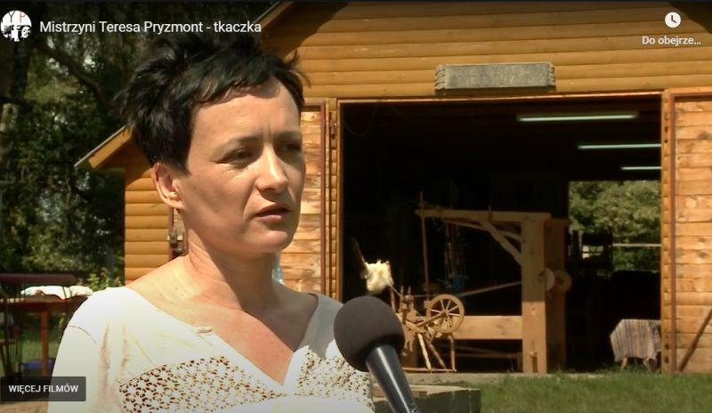

If there are several callers, we change the sides on which we record them. If the first one was on the left, the next one should be on the right. The tiny microphone connected to the wireless microport is of excellent quality and very comfortable to use. It's also much cheaper than a few years ago. Another option is to use iPad headphones as a microphone, the recording quality is very good.
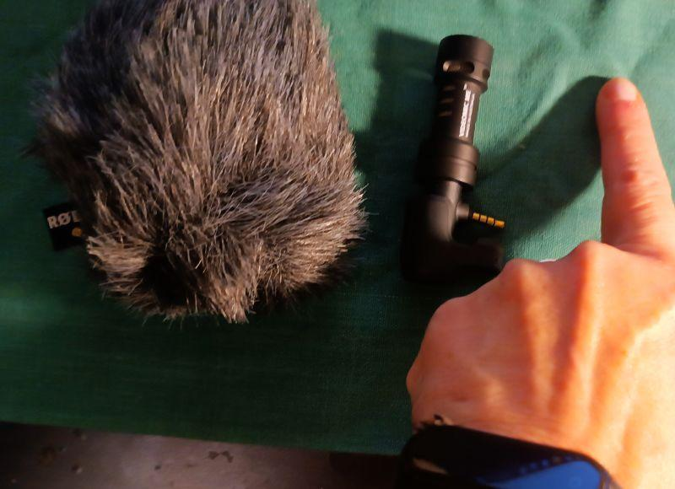

"Off" - a recording from behind the frame, otherwise a voice-over. After preparing the script for editing, the voiceover is recorded in a recording studio by a professional reader or we do it in a more mode.
We can use a special small microphone for a smartphone or iPhone. It is small, the length of the index finger. We put it on the phone, we are looking for a quiet place - Amy Winehouse recorded her first album in the closet. Because there was great soundproofing there, a lot of clothes that muffled the noise and brought out a beautiful sound.

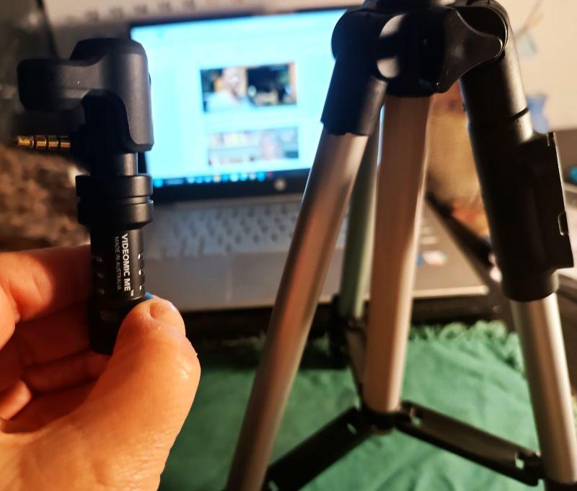

For recording outdoors, when there is wind, we can use a cover behind the artificial fur, which protects against noise.
For off recordings, we recommend using a small tripod - its height is the length of three index fingers. It gives a sense of security and the recording is stable.
The tripod is foldable, takes up little space and is very cheap.

Video Shooting
The work on the film can be divided into three main stages: pre-production, production and post-production. Pre-production is the organizational stage consisting of all the arrangements and all the activities that need to be done to fully prepare to start recording. Production is the recording of footage including sound, the so-called raw material. Post-production is the editing part.

When working on the script, during the pre-production phase, it is determined the purpose of the film, so at this stage is when all the involved parties should be thinking about who the film is aimed at. Any film, just like journalistic material, should give the viewer answers to the following questions: WHAT, WHO, WHEN, HOW and WHY IS THIS IMPORTANT?

The video, so as not to bore, should last a maximum of 5 minutes, and thinking about an interesting form of presentation of the topic could be helpful: a sense of humor and cheerful mood of the film are highly recommended.

Production is the organization and recording of footage with sound, or what is known as raw footage. The basic elements of the producer's activities are:
- formal and legal regulations;
- preparation of the interlocutor(s), clarification of the purpose, subject of the conversation, agreement on the recording time, also with the cameraman;
- preparation of the recording site - in a building or outdoors, checking conditions, lighting and sound (if the room is empty, high reverberation may be in it).

The shooting is usually done by the operator:
- the cameraman must know the script, the planned time of the film to record all the elements of the film;
- checking the lighting, it is worth taking care of an extra lamp in the room or a blender, which is a film screen that reflects light, used on the set; this is especially useful for outdoor recording in bright sunlight; it is worth remembering that the best light in the summer in the open air is in the early morning or late afternoon before sunset; never shoot against the light, against a window or against the sun;
- recording sound, checking the microphone beforehand, if you are recording with a camera or a cell phone, take care to have an additional microphone, preferably a condenser microphone that collects ambient noise; recording only with the microphone from the device will cause ambient noise, conversation, or passing cars to disturb the interviewee.

The basic mistakes easily avoidable in many amateur recordings are:
- jumping from motif to motif;
- short, jagged shots taken from the most unexpected perspective;
- quick camera zooms and zooms, very unstable images - unfortunately, this is often the reality recorded with a camera by someone who does not know the basic principles of the language of film.

Video Editing
Editing, or post-production, is the work of arranging the different parts of the film in the right order. It's also the color correction of the film and setting up the sound. These are the most time-consuming parts of working on a video. It is also in editing that special effects and additional sounds, including music, are possibly added. A voiceover - that is, sound from the off (outside the frame) - is also added. It is important to make sure that the sound is synchronized with the image. When you see an actor's mouth movement on the screen that does not match the sound you hear, this is known as asynchrony.
It is also important to prepare a script for editing the film with a timecode, an indicator of the time of a given shot shown in minutes and seconds. This is information for the editor, which fragment of the shot is to be used: if we write the file number of the shot, e.g. 7655, and specify the time, i.e. then it is clear which fragment we want to use. For example, from 0: 23 (or 23 sec.) from the words: "...a long time ago" to 0:51 (i.e. 51 sec,) to the words "I'm not complaining".
It happens a lot that there are not enough film shots and there is no material for punctuation. Then you can bail out with free high-resolution PNG photos available on the Internet. Open photo resources on the Internet europeana.eu, flickr.com, pixabay.com, pexels.com, unsplash.com.
As follow, a useful exercise that helps the post-production part of a video making.
Divide the sheet of paper in half - on the left write "WHAT YOU SEE", on the right "WHAT YOU HEAR".

What you see? VIDEO What you hear to? AUDIO
- close-up plan: on the woman's hands (8 seconds) - soft music ( it can be heard
- far plan - woman at the loom, barn door open, though all the film)
trees and fields visible (10 seconds);
- detail - fabric pattern in close-up;
- title of the film: "Mistress – Teresa Pryzmont, weaver";
- close-up plan on a woman who begins to speak - Off: lecturer reads the title over
100% - the statement of the woman
(60 seconds) Caption - Teresa Pryzmont, - 100% female statement (60 seconds)
weaver (speech covered with punctuation);
- distant plan - showing the house and
yard (12 seconds);
- demonstration of weaving technique - Off: Lecturer reads the biography of the weaver.
5 punctures - close plan (60 seconds);
8. 100% interview with ethnographer
(60 seconds) close plan + far plan and punctuations;
9. end credits - back logotype of the
authors preparing the film, Erasmus+
and EU logos, the year of film's
creation plus address of the website
where you can see other films.

Further reading
Free video editing applications: Windows Movie Maker and Movavi Video Editor:
https://www.movavi.com/adv/windows-movie-maker-review.html

Unit 6: Post-production of an online video

Introduction
In this didactic unit, future young facilitators who will take part in intergenerational encounters with senior people on the topics of technologies, ICTs, and digital content edition, will learn about the post-production of audiovisual content that will end up online. The information provided is very practical, and the description step by step easy to follow and adapt to a senior audience.
The first topic is about the usage of CapCut tool, while throughout the second topic it will be explained how to upload a video on a Youtube channel.

Learning objectives
- Edit and customise recorded videos
- Organise a YouTube channel by uploading finalised videos
- Learning by doing

Topics
- Editing Tools (CapCut App)
- Upload YouTube videos (Android)

Estimated duration of the unit delivery: 2 hours.

How to use CapCut App
CapCut is a free video editor developed by the same company that created the TikTok app. After its global launch in April 2020, this easy-to-use video editing app soon took a large share in the editing market. After all, the large user base of TikTok contributes to the growth of the CapCut app.
So, how to use CapCut to create videos easily for sharing or just for fun? We compiled the complete guide to make good edits using CapCut, covering everything from creating a new project, applying basic edits, venturing for advanced features, to exporting the video.
- Step 1. Install CapCut app and open it.
- Step 2. Tap the "New Project" icon to create a project.
- Step 3. Tap to select one or multiple video clips and hit Add.
- Step 4. Start editing on the timeline.

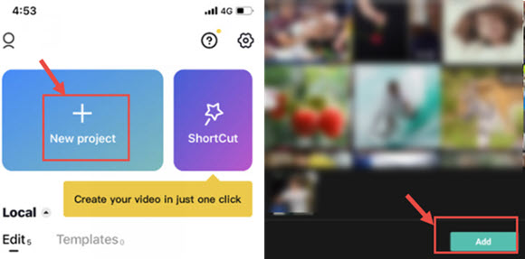
Tips:
- CapCut will save the project draft automatically. You can pause and resume editing anytime.
- For automatic quick editing, you can also use the ShortCut feature to create videos in 1-click.

Introducing the CapCut Interface
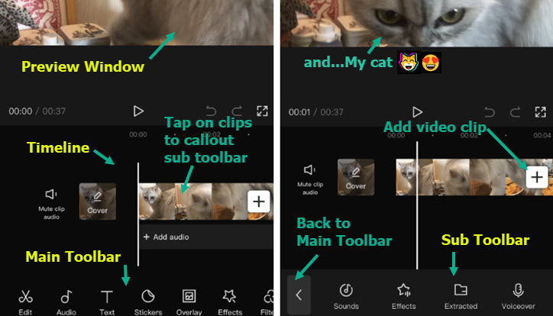

- Preview Window: You can playback video, or pinch, drag, rotate and interact with the clips directly inside the preview window.
- Timeline: You can assemble, arrange, and apply edits to video, audio, overlay, effects, and text tracks.
- Main Toolbar: All the tools you need can be found here. The Main Toolbar shows up when there is no clip selected on the timeline.
- Sub Toolbar: They are toolbars dedicated for different tracks and clips on the timeline. For instance, there are sub toolbars for videos clips, text, audio, overlays and so on.
You can also watch the video tutorial below.

How to do basic editing in CapCut
How to Trim Videos in CapCut
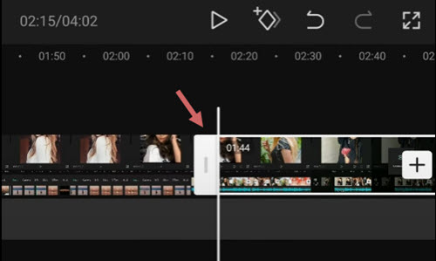
After adding videos to the timeline, follow these steps to trim videos in CapCut:
- tap the video clip, you shall see white frames around it;
- tap and hold on the white edge, and drag it to trim the video;
- you can also drag the opposite position to retrieve trimmed parts.
When you are trimming videos by dragging the edges, the adjacent clips will move along. In this way, there won't be gaps (and hence black screens) in your project.
If you want to trim out a section in the middle, you need to split the footage, and delete the clip in the middle. Read below.

How to Split Clips in CapCut
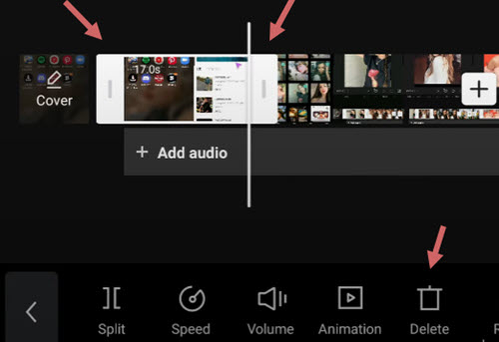
To split a video clip in CapCut, follow these steps:
- tap the video clip to make sure it is selected;
- hit the Split icon at the bottom of CapCut.
By splitting the video, you can perform the following edits:
- add transitions in between after creating the split;
- remove unwanted parts by tapping the split clip, and hit the Delete icon at the bottom of the screen;
- insert new clips in between two video clips.

How to Resize Videos in CapCut
When you are trying to share videos to certain social platforms, the original video you created for another platform may not fit. Resizing videos in CapCut can make your video best fit the social media, and offer better viewing experiences for your followers.
To resize videos in CapCut, follow these steps:
- tap the video clip that you want to change size;
- tap the Format icon at the bottom of the editor;
- choose a different aspect ratio.
For instance, if you want to change horizontal videos to vertical, so as to better fit TikTok, you can use the 9:16 dimension.
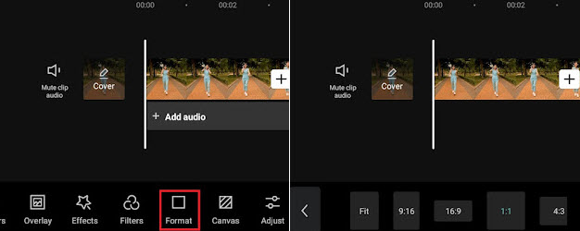
When resizing the video, it is inevitable that some parts may be cropped, or are surrounded by black bars. In such a case, you can use the Canvas feature to polish the video.
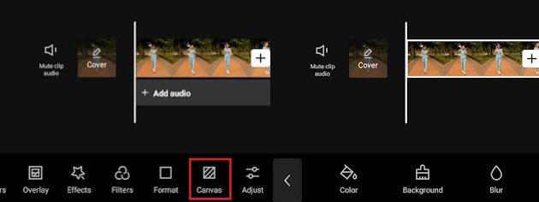
- After changing format, tap the Canvas icon on the toolbar at the bottom screen;
- tap the Color icon to change background color;
- use the Background feature to add pictures as the video background.

How to Mirror Video in CapCut
Mirror a video is a way to flip the video horizontally, or to create an interesting effect when two videos are put together side by side, while each one is mirrored to the other on the horizontal axis.
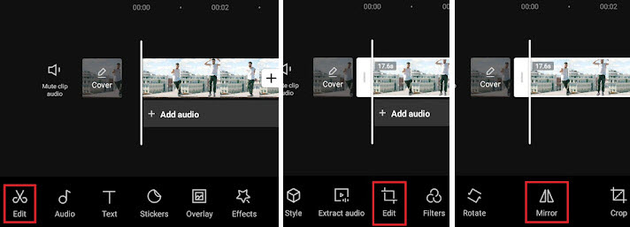
To mirror a video horizontally in CapCut, follow these steps:
- after importing the video clips into CapCut
- you shall see the toolbar pop up at the bottom, tap the Edit menu.
- Here will be another Edit option right between the Extract Audio and Filters tool, tap it;
- hit the Mirror tool inside the Edit option.

How to Rotate Video in CapCut
In CapCut, you can rotate the video to fix wrong orientations, or create the trendy rotation effects that features video zooming and rotating in animation.
- Rotate Video in CapCut to Change Orientation;
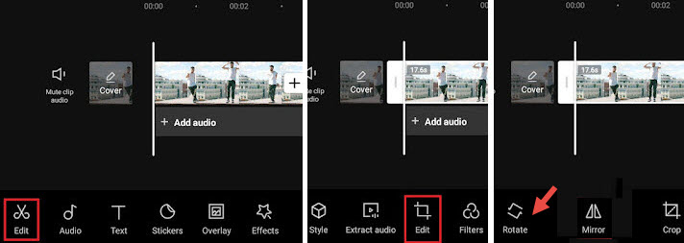
- create a new project, add video clips from your camera roll, and Hit the Add button;
- then, hit the first Edit button to go inside the video editing toolbar;
- tap the second Edit button, and hit Rotate.
Note:
If you want to rotate part of the video instead of the entire video clip, tap on the footage and split it before using the rotate function.
- Rotate Video in CapCut Using Keyframes to Create Motion Effects.
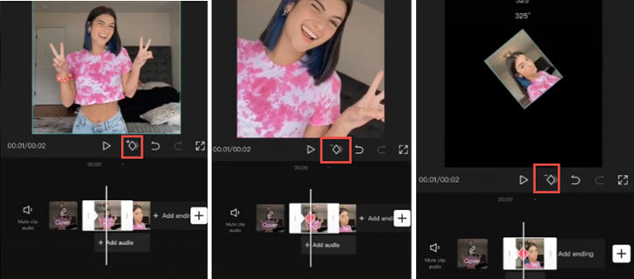
If you are trying to create video rotating effects, like those trendy videos that rotate videos and selfies photos, follow the steps below:
- import video clips or pictures to CapCut;
- tap on the clip, and tap the Keyframe icon to add a Keyframe. The Keyframe icon sits under the preview window (see screenshots above), next to the Play button;
- tap on the clip and swipe to the right to move to a new position, tap the Keyframe button again to add another Keyframe.
- While staying on the second Keyframe, put two fingers in the preview window to pinch and rotate the clip;
- then, repeat step 3 to move forward and create the third Keyframe, and repeat step 4 to pinch and rotate the clip. You can rotate it to 360 degrees, 180 degrees or any angle that you like.
Playback and you shall see the clip rotating in motion. You can also make adjustments accordingly until you are happy with the result.
A little explanation here if you are curious about how the Keyframe works: for the first Keyframe, it keeps the original state of the clip, without another rotation or zoom-in, then in the second Keyframe, we rotate the clip. Therefore, from Keyframe 1 to Keyframe 2, the video starts to animate from the original state to another state with different rotation angle and scale, thus resulting in animation.

How to Change Speed in CapCut
CapCut offers two modes to change speed: Normal or Curve. The Normal option allows you to speed up or slow down the video at a constant speed, such as 2x, 4x, 8x, etc.; the Curve option opens up to more editing possibilities, with the speed changing non-linearly to create impactful speed ramping effects.
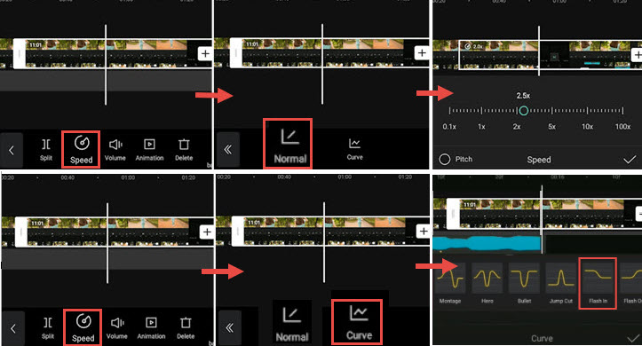
To use the constant speed modifier in CapCut, follow these steps:
- tap the video clip on the timeline, and hit the Speed icon;
- hit the Normal option to change the speed at the constant rate;
- drag the slider the slow down video to 0.1x or speed up to 100x.
You can toggle the Pitch option to decide whether to alter audio pitch when the video speed is changed.
To use the speed curves in CapCut, you can read the detailed guide to make velocity effects, including auto velocity effects.
To ease the speed when creating transitions, 3D zoom effects, or using keyframes, you can use the graphs feature in CapCut.
With the speed modifier in CapCut, you can make an interesting Slomo video (Slow motion) to highlight a key moment, such as creating the bullet time effects.

How to Reverse a Video in CapCut
Reversing a video can create interesting effects, such as broken glasses restored or torn paper merged into one.
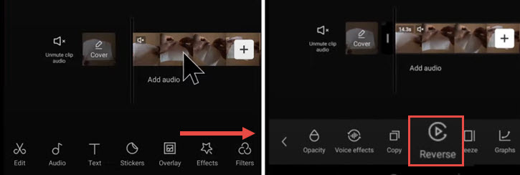
- Add video to the project in CapCut.
- Tap on the video clip, and swipe the toolbar at the bottom.
- Swipe all the way to the right until you see the Reverse icon.
- Tap on it to Reverse the Video.

How to Replace a Clip in CapCut
Replacing videos or pictures in CapCut is a handy feature. With it, you don't need to go through the hassle of trimming and adjusting the length of the newly add video clip to make it fit in, or re-apply effects again. The replaced video clip shares the same duration and effects of the original clip.
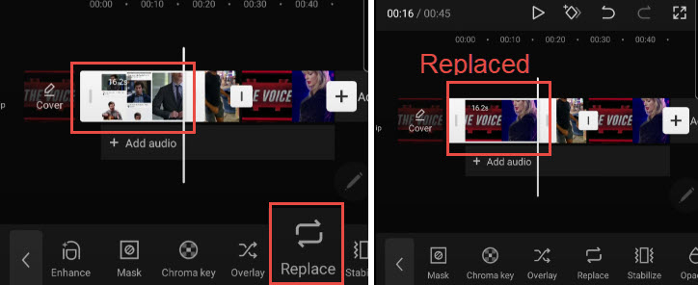
- Tap on the video clip that you want to replace. If you prefer to replace part of the footage, you can use the Split tool to cut up the footage, and tap the segment to swap.
- Tap and swipe the toolbar at the bottom, all the way to the right until you see the Replace icon.
- Tap Replace and find the video clip that you want to add.
Note:
The duration is set to be the same length to fill in the slot, still you can swipe the footage back and forth to make sure the parts you want are included in that settled duration.

How to Add Video Transitions in CapCut
Many trendy transitions in TikTok are 1-click templates in CapCut Video Editor. With these templates, you can create cool transitions without editing experience.
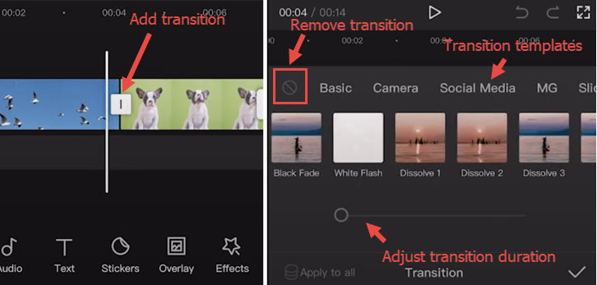
- Import two or more videos into CapCut project, or split a long video into two parts.
- Click the icon between two clips to enter the transition panel.
- Apply transition templates and playback to find one you love.
Note:
You can tap the transition icon again to adjust or delete transitions.
- Drag the slider to adjust the transition timing.
- Tap the forbidden icon to stop applying any transition preset.

How to Use Overlays in CapCut
Using the overlay feature in CapCut, you can add videos, pictures and text on top of the main clip, thus creating Picture in Picture effect, special title effects, or use it in combination with green screen effects and more. To add overlays to CapCut, follow these steps:
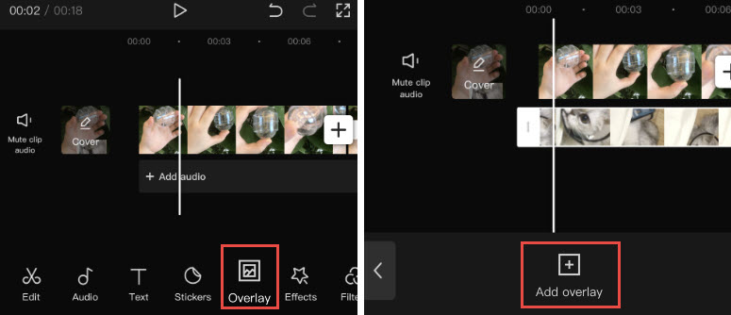
- import video or picture into the project as the main clip;
- click the Overlay icon in the toolbar. If you cannot find the Overlay icon, make sure not to tap the main video clip;
- in the new window, tap Add Overlay;
- then browse the video or picture files and select one to add.
Note:
You can repeat the steps to add more overlays on the timeline.
To edit overlays in CapCut, follow these steps:
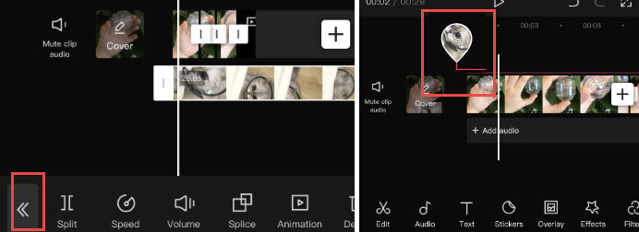
- tap on the Overlay track, and you shall see the editing tools. You can split, trim, change volume, and so on in the same way you edit the main clip;
- tap the double arrow icon once you finish editing the Overlay clip. It will take you back to the main timeline;
- to revisit the Overlay editing panel, click the waterdrop-shaped thumbnail.
Tips:
- if your overlay is longer than the main clip, the rest the video will show black screens with only the overlays;
- you can tap the overlay clip and split or trim it;
- to change the position of the overlay clip on the timeline, you can tap and keep pressing on the overlay clip to move it.

How to Put Two Videos Side by Side in CapCut (or Create Split Screen Effect)
When you add two or more clips on different tracks in the timeline, and make they aligned on the timeline, these clips will show up in the preview window simultaneously in the same screen.
You can crop or use the split screen features to decide the parts to show and hide, or change the shapes of the split screen. The video tutorial below is easy to follow.
To get started, add main video to the timeline, and tap Overlay to add overlay video.
- Tap the Mask icon at the bottom panel.
- Tap the Split icon, and move the split line in the preview window.
- You can also add more videos side by side by repeat steps above.
- Besides using the Split template, you can also use the Filmstrip template and so on.

How to Use Green Screen in CapCut
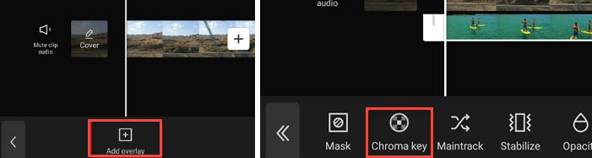
CapCut offers the Chroma Key feature to remove colors such as green screen.
- Import the main video to the project, and add overlays on top of the video.
- Find the Chroma Key icon in the overlay video's editing toolbar.
- Use the color picker to identify the color to remove.

How to Edit Text in CapCut
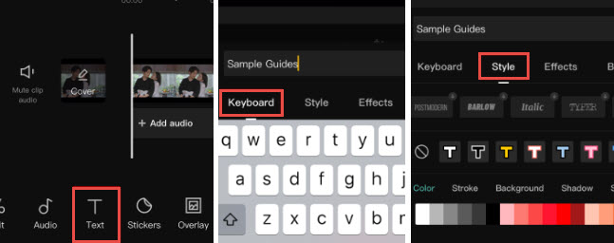
Adding text is easy and quick in CapCut:
- create a New Project and import video, audio, pictures when needed;
- tap the Text icon at the bottom toolbar;
- type in the text as you like, and adjust its color, fonts, shadow, etc.;
- after adding text to the timeline, you can drag its edge to make it longer or shorter, depending on how long you prefer it the stay on the screen.
Next to the Style tab for text, you can also apply Effects, Bubble, and Animation to the Text. Since they are presets, you don't need advanced editing skills to deal with the settings.

How to Make Text Transparent in CapCut
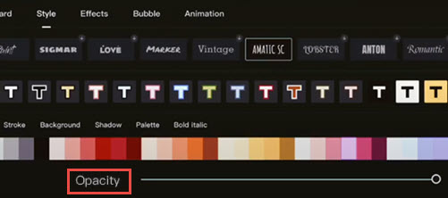
After adding text to the video in CapCut, you can adjust its transparency to create nice styles. For instance, it can be used as a way to add watermarks to the videos in CapCut.
- Tap Text icon, type in the text as you like, and hit the confirm button;
- In the style tab, drag the Opacity slider to change the transparency of the text and titles.

How to Use Text Tracking in CapCut
The text tracking feature in CapCut can automatically animate the text, in a way that the text follows a moving object in the video designated by you.
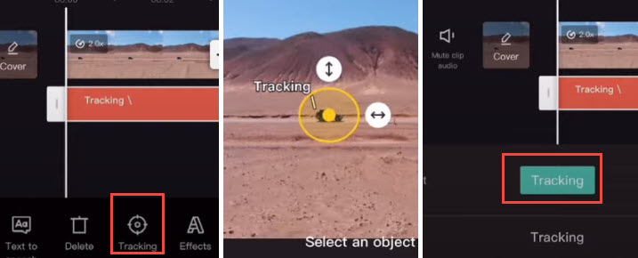
- Import video into CapCut project, and tap the Text icon.
- Add text to the video, and tap on that text clip.
- Swipe at the bottom toolbar until you see Tracking.
- Narrow down the area to track the object by dragging the arrow, and place the anchor on the central part of the moving object.
- Tap the green Tracking button to start auto-tracking.
When it's done, you shall see the text move along with the chosen object.
Note: You can ease out and ease in the tracking motion by applying the graphs feature.

How to Create the Text Behind Person Effect
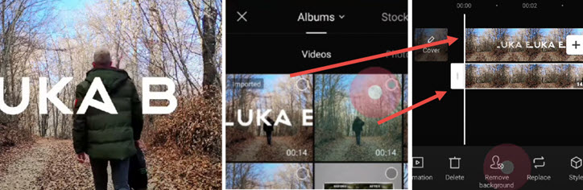
When combining text editing with other features in CapCut, you can create trendy text effects as other creators. Placing the text behind a person is such an example.
- Add text to the video as you normally do, and export that video clip.
- Create a new project, and import that video as the main video track.
- Tap overlay to import the raw video (one without text) as the overlay track.
- Use the Move background feature to remove the background, and it's done.
For a detailed guide, you can watch the video tutorial by Luka, shown below.

How to Edit Audio in CapCut
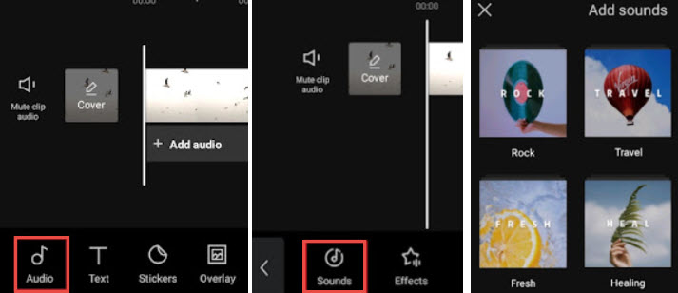
You can add background music, sound effects and other audio to the video by using the stock audio library in CapCut. These stock media files are royalty free, meaning you can upload the video to YouTube and other social platforms without copyright infringement.
Besides using stock music, you can also use CapCut to extract music from your favorite videos. With this method, you might not be able to share the video to the public, but only for personal sharing.
- Add the footage to a new project, and tap the Audio icon at the toolbar.
- Hit Sounds to open up the stock library, and pick your favorite track to add.
- You can tap on the added audio clip to trim, split or change its speed.

How to Change Audio Volume in CapCut
To make video louder or mute it, you can use the volume option in audio editing.
- For background music and environment sound inside the video, you can tap on the video track, and hit the Volume icon to change the loudness.
- You can also tap on the video, hit Extract to separate that audio onto the dedicated audiotrack. Then you can tap the audio clip and use the Volume tool on it.

How to Use Auto Caption in CapCut
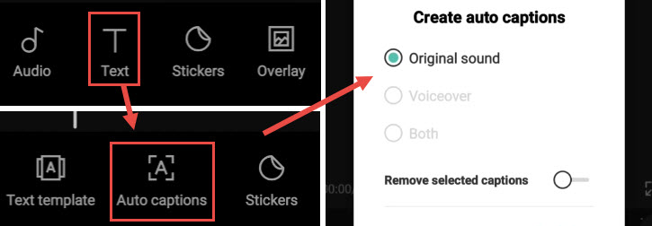
If you love the speech to text feature in TikTok, chances are you will also be needing the speech to text feature. Using CapCut, you can turn video sound to captions automatically, thus saving time as you won't need to manually add captions.
- Create a new project and add the video.
- Hit the Text icon from the toolbar. Do not tap on the video, otherwise, you will be directed to the video editing toolbar, where you won't see the Text icon.
- Hit Auto Captions. It sits in between the Text template and Stickers features.
- Choose to create auto captions from the original sound in the video, voiceover, or both.
- Wait for the app to finish analyzing and adding the text as captions.
You can playback and check if the caption is accurate. If you prefer to make adjustments, tap the Batch Edit icon to callout the keyboard, and correct the word when needed.

How to apply advanced editing in CapCut
How to Add Effects in CapCut
CapCut has many ready-to-use effects to enhance your video easily. It includes both video effects to add enchanting FX and body effects to polish your skin, figure, and so on.
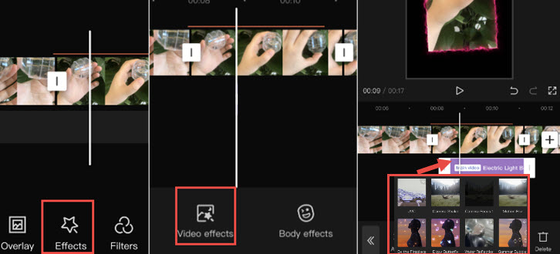
- Tap on a video clip and hit the star-shaped Effects icon.
- Tap Video Effects or Body Effects.
- Use the presets to polish the video clip. The effects will be shown as a purple clip underneath the main video.
Note:
Once you go back to the main timeline, you won't see the purple clip, there is instead a colored line about the video clip, indicating that segment has effects applied. You can always revisit and edit or remove the effects by tapping the Star-shape Effects icon again.

How to Make a Picture Move in CapCut
To make a picture move in CapCut, you need to use the Keyframe features. You can keyframe the position, scale, rotation angle, crop percentage and many other parameters in CapCut, so that the clip will transform from status 1 in Keyframe 1 to status 2 in Keyframe 2, thus creating the desired motion.
- After adding the picture as overlays on top of the video, tap on the picture clip.
- Swipe the clip to place the playhead at the point where you want the picture to start move.
- Hit the Keyframe icon under the preview window to add the first Keyframe.
- Move the picture to another position in the preview window, and hit the Keyframe icon again to add the second keyframe.
Playback the video, you shall see the picture move from position 1 to position 2. Once you get the hang of CapCut editing, you can also up your game and learn how to add 3D Zoom in effects in CapCut. For quick editing and to keep up with the trend, you can also use CapCut templates to have fun.

Will I Lose Everything If I Delete CapCut?
Yes, your projects and drafts will be deleted along with the app. If you are on iOS, you can choose to "offload" the app, which will delete the application itself, while keeping the documents and data inside it. However, it is not guaranteed that everything will be intact.

How to Export the Video from CapCut
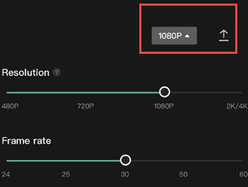
After editing the video, you can click the Export button in the top right corner.
CapCut support exporting video up to 4K, here are the export settings to tweak with:
- Resolution: 480p, 720p, 1080p, 2K/4K;
- Frame Rate: 24, 25, 30, 50, 60;
- Smart HDR: Option to turn video into "smart" HDR video.

How to upload a video to the YouTube channel
Uploading videos to YouTube is possible in a few easy steps. Use the instructions below to upload your original videos from a computer or from a mobile device. It has to be noted that uploading may not be available with supervised experiences on YouTube.
If you desire to upload a video from your mobile phone, you can use YouTube Android App, by recording a new video or selecting an existing one. Moreover, it could be interesting to know the latest news, updates, and tips on the YouTube Creators channel.
- Open YouTube app.
- Tap Create Upload a video.
- Select the file you’d like to upload and tap NEXT.
  - If your video is 60 seconds or less and has a square or vertical aspect ratio, it will be uploaded as a Short.
  - (Optional) If your video is longer than 60 seconds and has a square or vertical aspect ratio, you can tap “Edit into a Short” to trim your video and upload it as a Short.
​If you close the upload experience before you finish choosing your settings, your video will be saved as a draft on your Content page.
Add important details to your video.

Thumbnail | The image viewers will see before clicking your video.
Title | The title of your video.
Description | Info that shows below your video. For video attributions, use the following format:  For formatted text in your descriptions, use the following format: [Channel Name]|[Video Title]|[Video ID].  For formatted text in your descriptions, use the following format:  - *Sample* for bold text.  - _Sample_ for italicized text.  - -Sample- for strikethrough text.
Visibility | Choose the privacy settings of your video to control where your video can appear and who can watch it.  If you're in the YouTube Partner Program, you can set your video to unlisted or private until checks are finished. To get notified once checks are complete, you can opt-in to get a notification in the YouTube Studio app.  Note: We’re slowly rolling out this feature. ​​
Location | Enter the location where your video was filmed.
Playlist | Add your video to one of your existing playlists, or create a playlist.
Click NEXT to select your audience.
Audience | To comply with the Children’s Online Privacy Protection Act (COPPA), you’re required to tell us whether your videos are made for kids.
Age restriction | Age-restrict videos that may not be appropriate for all audiences.
If you wish, instead, to upload a video from a laptop, these are the instructions to follow:
- go to http://youtube.com;
- on the top right corner, click on SIGN IN if you are not logged into your account already.
- If you do not have an account, please create one;
- once you are signed into your account, click the camera with the plus (+) sign icon on the top right of your screen.
- Click the upload video option.
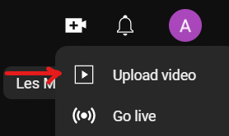
- The Upload Video screen will pop up. To upload a video you can either drag and drop the video from your computer or click SELECT FILE to locate your video from your files.
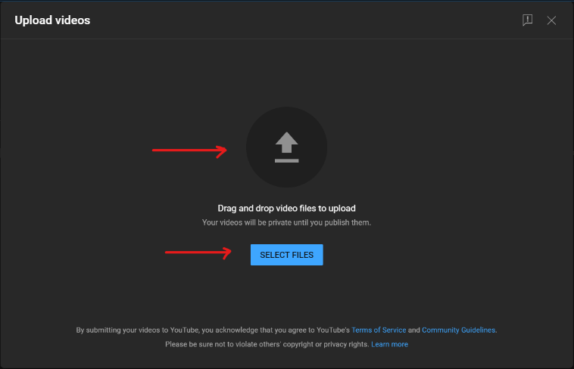
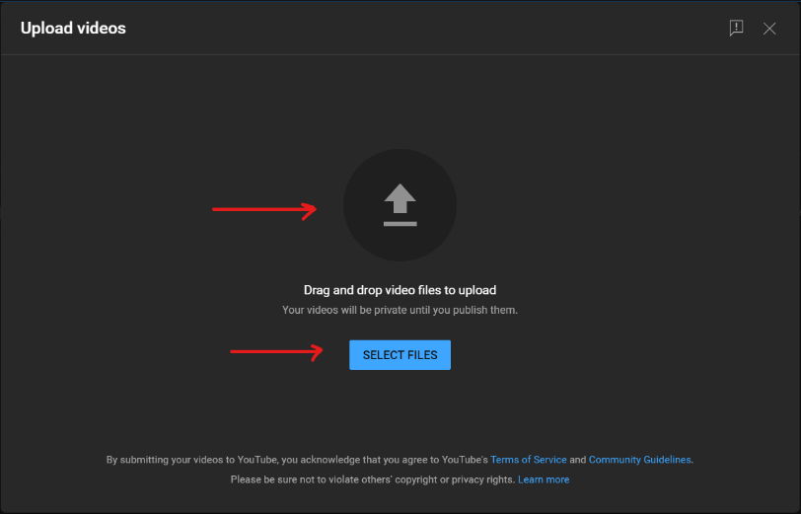
- If you choose the SELECT FILE option, a file Explorer screen will pop up. Locate your file and then click Open.
- You will then see the upload progress screen. This process will take a few minutes depending on how long your video is.
- You can add your video title, a description and a thumbnail. You can either select a thumbnail from the available pictures or upload your own.
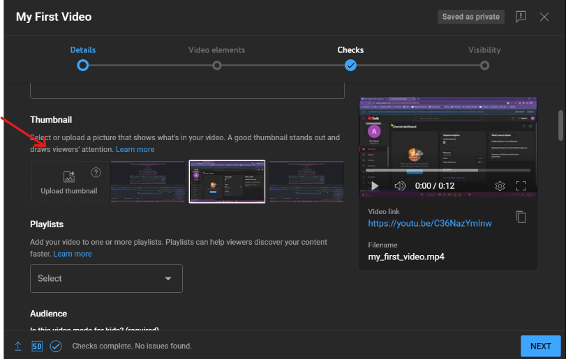
- Before you proceed to the next step, it is mandatory to select the option if the video is made for kids or not. You can find the audience options after the thumbnail selection.
- Skip Video elements and Checks by clicking Next.
- Under Visibility, select the preferable option for your video. Private videos are visible to you and people you choose, Unlisted videos are visible to anyone with a link and Public videos are visible to everyone.
- When you are done with all your settings, click Save.
- You have now uploaded your video onto YouTube.
- Your video will show up in your channel, to the Content tab.

Further reading
Useful YouTube tutorials:
https://www.wix.com/blog/2019/02/how-to-upload-video-youtube-guide/
https://www.youtube.com/watch?v=JeEzkb1X554&ab_channel=TheFigCo

Bibliography
Digiarty Software (no date). Available at: https://www.videoproc.com/video-editapp+CapCutor/how-to-use-capcut.htm.
Upload YouTube videos - Computer - YouTube Help (no date). Available at: https://support.google.com/youtube/answer/57407?hl=en.

Further information:

Project website: https://trainingclub.eu/age/
Project coordinator website: https://www.asociaciondeses3.com/thelearningage

